

INTRODUCTION TO DATA SCIENCE

CHETLA AKSHITHA
237Z1A6729
CSD-A
Exp - 5: Write an R program to draw a pie chart, 3D pie chart, and bar chart by considering a suitable CSV file.
> install.packages("ggplot2")
> library(ggplot2)
> data<-read.csv("C:\Users\Student\Downloads\salary_Data.csv")
Error: '\U' used without hex digits in character string (<input>:1:20)
> data<-read.csv("C://Users//Student//Downloads//salary_Data.csv")
> head(data)
YearsExperience Salary
1 1.1 39343
2 1.3 46205
3 1.5 37731
4 2.0 43525
5 2.2 39891
6 2.9 56642
> tail(data)
YearsExperience Salary
25 8.7 109431
26 9.0 105582
27 9.5 116969
28 9.6 112635
29 10.3 122391
30 10.5 121872
> data

YearsExperience Salary
1 1.1 39343
2 1.3 46205
3 1.5 37731
4 2.0 43525
5 2.2 39891
6 2.9 56642
7 3.0 60150
8 3.2 54445
9 3.2 64445
10 3.7 57189
11 3.9 63218
12 4.0 55794
13 4.0 56957
14 4.1 57081
15 4.5 61111
16 4.9 67938
17 5.1 66029
18 5.3 83088
19 5.9 81363
20 6.0 93940
21 6.8 91738
22 7.1 98273
23 7.9 101302
24 8.2 113812
25 8.7 109431
26 9.0 105582
27 9.5 116969
28 9.6 112635
29 10.3 122391
30 10.5 121872

> df<-read.csv("C://Users//Student//Downloads//salary_Data.csv")
salay_by_experience<-aggregate(Salary~YearsExperience,data=df,sum)
> pie(salary_by_experience$Salary,
+ labels=salary_by_experience$YearsExperience,
+ main="Total Salary Distribution by Years of Experience",
+ col=rainbow(length(salary_by_experience$YearsExperience)))\

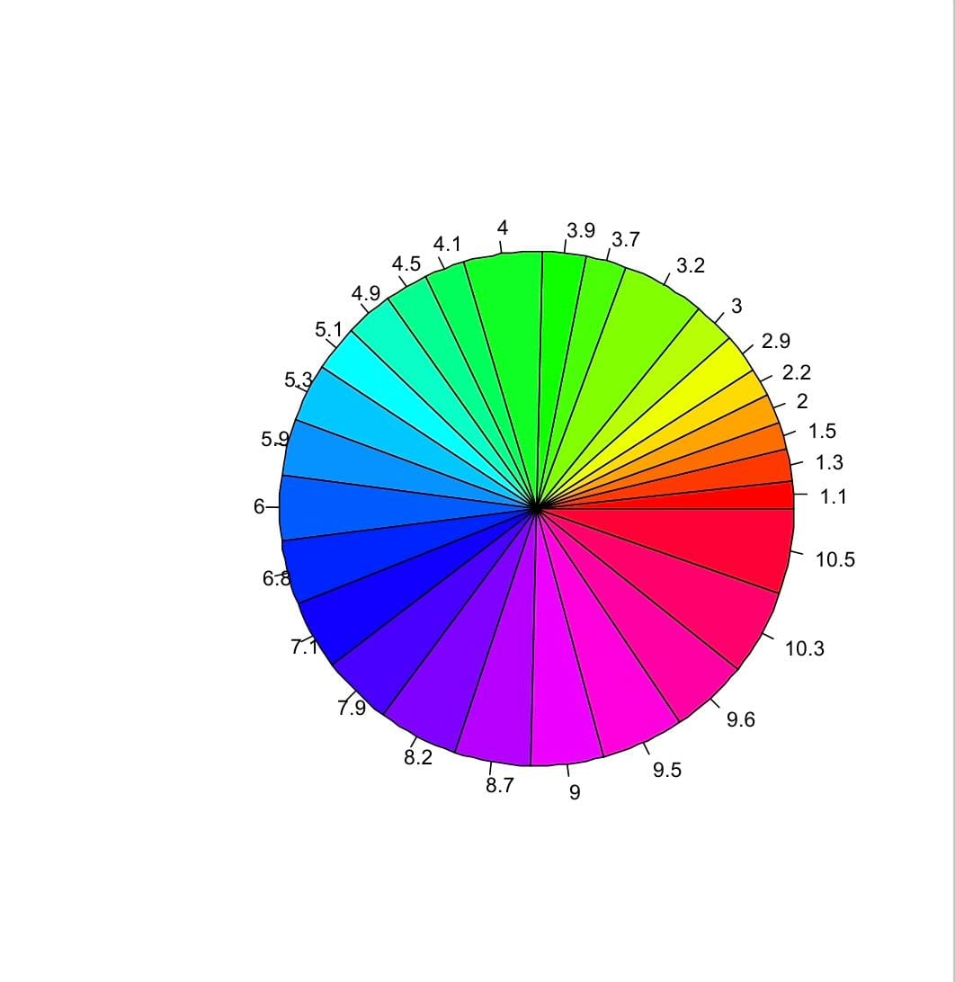
>install.packages("plotrix")
> library(plotrix)
> data<-read.csv("C://Users//Student//Downloads//salary_Data.csv")
> years_of_experience<-data$YearsExperience
> salary<-data$Salary
> pie3D(salary,labels=years_of_experience,main="3D pie chart of salary vs Years of Experience",
+ col=rainbow(length(salary)),explode=0.1)
>ggplot(data,aes(x=YearsExperience,y=Salary))+
+ geom_bar(stat="identity",fill="red")+
+ labs(
+ title="years of Experience vs Salary",
+ x="years of Experience",
+ y="Salary",
+ )
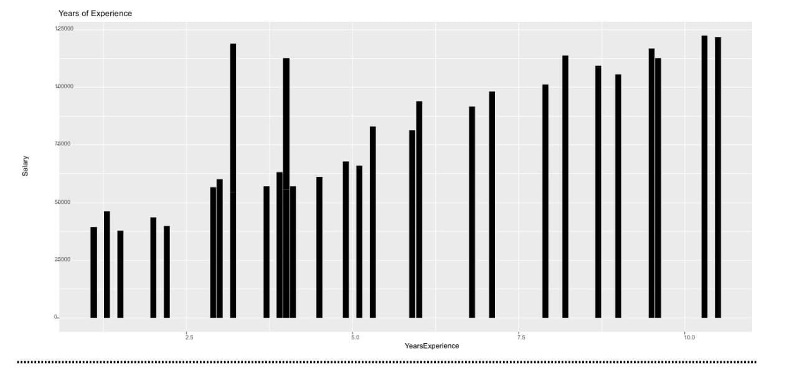
Exp - 6: Create a CSV file having Speed and Distance attributes with 1000 records. Write an R program to draw i) Box plots ii) Histogram iii) Line Graph iv) Multiple line graphs v) Scatter plot
> set.seed(123)
> speed<-sample
> speed<-sample(40:120,1000,replace=TRUE)
> Distance<-sample(50:120,1000,replace=TRUE)
> df<-data.frame(speed,Distance)
> write.csv(df,"speed_distance_data.csv",row.names=FALSE)
> df<-read.csv("speed_distance_data.csv")
> head(df)
Speed Distance
1 70 59
2 118 111
3 90 114
4 53 96
5 106 63
6 81 120

> boxplot(df$speed,df$Distance,
+ names=c("speed","Distance"),
+ main="Box plot of speed & distance",
+ ylab="values",
+ col=c("blue","pink"))
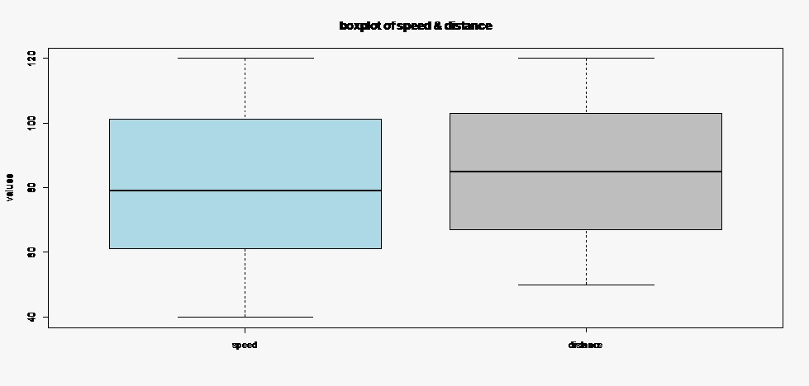
>hist(df$speed,
+ main="histogram of speed",
+ xlab="speed(km/h)",
+ ylab="frequency",
+ col=("violet"))

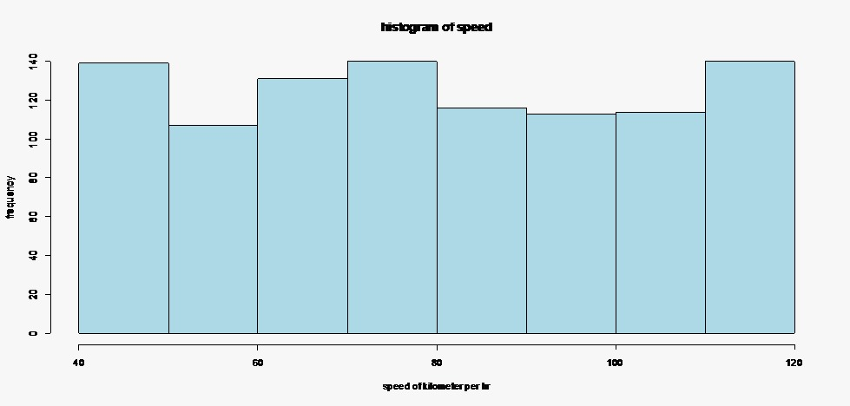

> hist(df$Distance,
+ main="histogram of distance",
+ xlab="distance(km/h)",
+ ylab="frequency",
+ col=("green"))
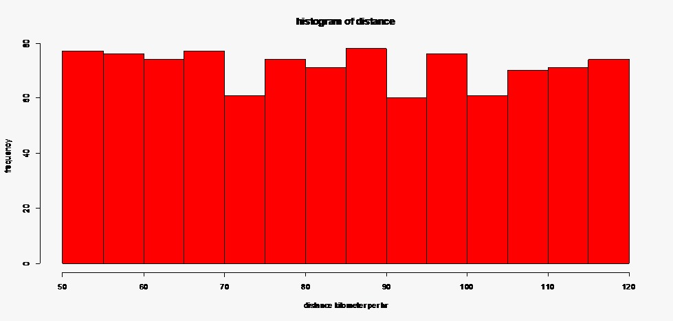

> plot(df$speed,df$Distance,type="l",
+ col="pink",lwd=2,
+ main="line graph of speed and distance",
+ xlab="index",ylab="speed(km/h)")
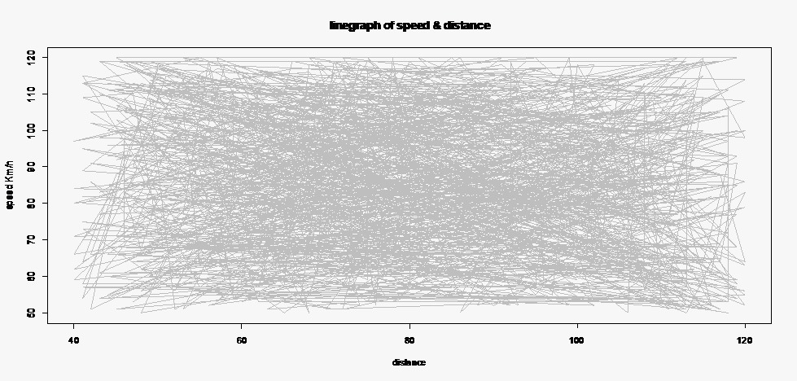
)>plot(df$Speed,df$Distance,type="l",xlab="speed",ylab="Distance",main="LinePlot",col="black")
>lines(df$Speed,col="red",lwd=2)

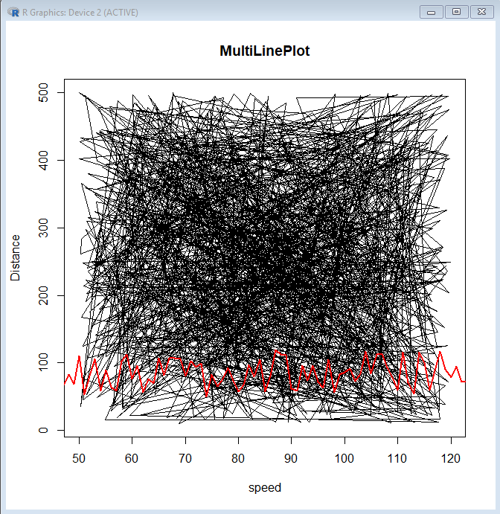

> plot(df$speed,df$Distance,col="red",pch=16)
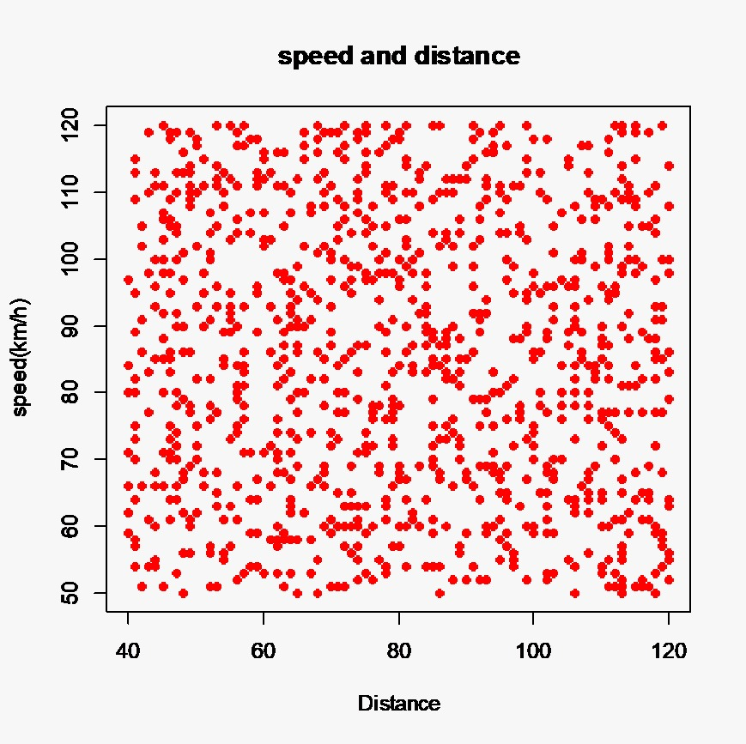
Exp - 8: Write an R program to read a CSV file and analyze the data in the file using EDA (Explorative Data Analysis) techniques.
> data<-read.csv("C://Users//siraj//Downloads//student_Data.csv")
> data
ID NAME AGE GENDER SALARY
1 11 siraj 25 male 50000
2 12 ajju 34 male 55500
3 13 siri 21 female NA
4 14 nikil 24 male 48000
5 15 nani 25 male 52000
6 16 keerthi 22 female 51000
7 17 <NA> 28 male 77000
8 18 ravi 27 male 63000
9 19 sri 29 female 53000
10 20 srija 31 male NA
11 21 raju 25 male 66000
12 22 kavya 30 female 71000
13 23 uma 32 female 62000
14 24 sam 33 female 54000
15 25 raju 20 male 55000
> sum(is.nan(data$SALARY))
[1] 0
> data$SALARY[is.na(data$SALARY)]<-mean(data$SALARY,na.rm=TRUE)
> data$NAME[is.na(data$NAME)]<-"Unknown"
> data

ID NAME AGE GENDER SALARY
1 11 siraj 25 male 50000.00
2 12 ajju 34 male 55500.00
3 13 siri 21 female 58269.23
4 14 nikil 24 male 48000.00
5 15 nani 25 male 52000.00
6 16 keerthi 22 female 51000.00
7 17 Unknown 28 male 77000.00
8 18 ravi 27 male 63000.00
9 19 sri 29 female 53000.00
10 20 srija 31 male 58269.23
11 21 raju 25 male 66000.00
12 22 kavya 30 female 71000.00
13 23 uma 32 female 62000.00
14 24 sam 33 female 54000.00
15 25 raju 20 male 55000.00
> duplicate<-data[duplicated(data),]
> print(duplicate)
[1] ID NAME AGE GENDER SALARY
<0 rows> (or 0-length row.names)
> data<-data[!duplicated(data),]
> head(data)
ID NAME AGE GENDER SALARY
1 11 siraj 25 male 50000.00
2 12 ajju 34 male 55500.00
3 13 siri 21 female 58269.23
4 14 nikil 24 male 48000.00
5 15 nani 25 male 52000.00
6 16 keerthi 22 female 51000.00

hist(data$AGE,main="AGE Distribution",xlab="AGE",col="blue",breaks=5)
> boxplot(SALARY~GENDER,data=data,main="SALARY+Distribution by GENDER",
+ ylab="SALARY",xlab="GENDER",
+ col=c("pink","green"))

barplot(table(data$GENDER),main="GENDER Distribution",col=c("violet","maroon"))

Exp - 9: Write an R program to illustrate Linear Regression and multi-linear Regression considering a suitable CSV file.
> install.packages("ggplot2")
> library(ggplot2)
> data <- read.csv("C://Users//siraj//Downloads//Salary_Data.csv")
> linear_model <- lm(Salary ~ YearsExperience, data = data)
> summary(linear_model)

Call:
lm(formula = Salary ~ YearsExperience, data = data)

Residuals:
Min 1Q Median 3Q Max
-7958.0 -4088.5 -459.9 3372.6 11448.0

Coefficients:
Estimate Std. Error t value Pr(>|t|)
(Intercept) 25792.2 2273.1 11.35 5.51e-12 ***
YearsExperience 9450.0 378.8 24.95 < 2e-16 ***
---
Signif. codes: 0 ‘***’ 0.001 ‘**’ 0.01 ‘*’ 0.05 ‘.’ 0.1 ‘ ’ 1

Residual standard error: 5788 on 28 degrees of freedom
Multiple R-squared: 0.957, Adjusted R-squared: 0.9554
F-statistic: 622.5 on 1 and 28 DF, p-value: < 2.2e-16

> ggplot(data, aes(x = YearsExperience, y = Salary)) +
+ geom_point() +
+ geom_smooth(method = "lm", col = "red") +
+ labs(title = "Linear Regression: Salary vs YearsExperience",
+ x="YearsExperience",
+ y= "Salary")
`geom_smooth()` using formula = 'y ~ x'
>
multi_linear_model <- lm(Salary ~ YearsExperience,data=data)
> summary(multi_linear_model)

Call:
lm(formula = Salary ~ YearsExperience, data = data)

Residuals:
Min 1Q Median 3Q Max
-7958.0 -4088.5 -459.9 3372.6 11448.0

Coefficients:
Estimate Std. Error t value Pr(>|t|)
(Intercept) 25792.2 2273.1 11.35 5.51e-12 ***
YearsExperience 9450.0 378.8 24.95 < 2e-16 ***
---
Signif. codes: 0 ‘***’ 0.001 ‘**’ 0.01 ‘*’ 0.05 ‘.’ 0.1 ‘ ’ 1

Residual standard error: 5788 on 28 degrees of freedom
Multiple R-squared: 0.957, Adjusted R-squared: 0.9554
F-statistic: 622.5 on 1 and 28 DF, p-value: < 2.2e-16

> predictions <- predict(multi_linear_model, newdata = data)
> ggplot(data, aes(x = Salary, y = predictions)) +
+ geom_point(color = "red") +
+ geom_abline(slope = 1, intercept = 0, color = "blue") +
+ labs(title = "Actual vs Predicted Salary (Multiple Linear Regression)",
+ x= "Actual Salary", y = "Predicted Salary")

